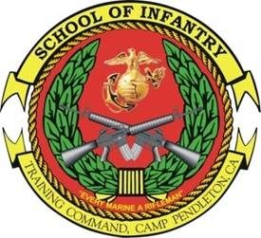 INFANTRY SMALL UNIT 
LEADER COURSE
- Purpose: To develop the leadership, decision making ability, and adaptive expertise of the infantry sergeant. The course exercises critical thinking, supports cognitive development, and challenges the small unit leader to solve complex problems. This environment will enhance the small unit leader’s ability to understand and employ the art and science of combined arms.
- Task List:
  - 2000 Level:
    - Fire support
    - Patrolling
    - Offensive tactical measures and operations
    - Defensive tactical measures and operations
    - Military operation in urban terrain
    - Conduct sustainment and integrate training
- Methodology: Students are placed in a succession of scenarios progressing in duration and complexity. The scenarios are executed as tactical decision games, sand table exercises, decision forcing cases, field training, and live fire exercises. Instructors coach and mentor the students while providing objective and doctrinally-based assessments. Peers provide additional assessments and focused feedback while participating in decision-centric after action reviews. The course allows students the ability to develop their decision-making and adaptive leadership skills by demonstrating them in a training environment.
- Course Length: 5 Weeks / 30 Training Days

FY 14 Course Message
Command Screening Check List
Gear List

